Exploratory Data Analysis (EDA) for Compensation Strategy

1. Context and Data Trustworthiness
The goal of this EDA phase was to establish a clear understanding of the salary data structure and inherent relationships before building predictive models. This initial analysis is crucial for ensuring data quality, which directly impacts the trustworthiness of subsequent compensation policy recommendations.

Initial Data Quality Audit
The dataset consists of 6704 employee records across six attributes. An audit revealed a minor presence of missing values (NaNs) across all columns (Age, Gender, Education Level, Job Title, Years of Experience, and Salary).
Business Implication: To build a highly reliable model for sensitive policy decisions, data completeness is paramount. We chose the conservative approach of removing all rows with missing data using df.dropna(). This ensures that every data point used for modeling is complete, reducing the risk of bias from imputation techniques.
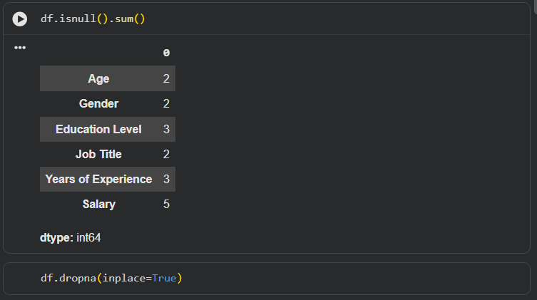
Figure 1: NULL values exist in dataframe

2. Analysis of the Target Variable (Salary)
Understanding the distribution of the target variable is the first step toward benchmarking and identifying potential pay anomalies.

Salary Distribution
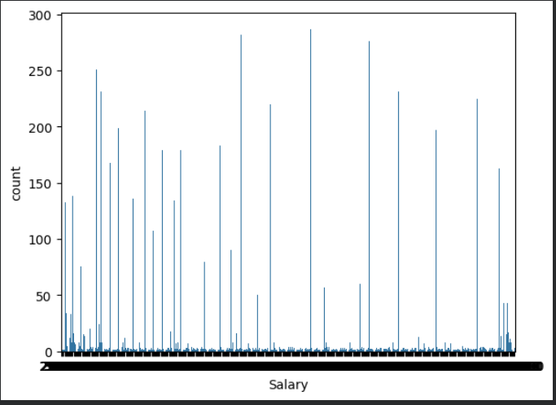
Figure 2: Salary Distribution

3. Key Predictors and Business Insights
The primary value of EDA is identifying which attributes drive compensation.

Years of Experience vs. Salary and Age vs Salary
A scatter plot comparing Years of Experience vs Salary and Age vs Salary revealed a strong, near-linear positive correlation.
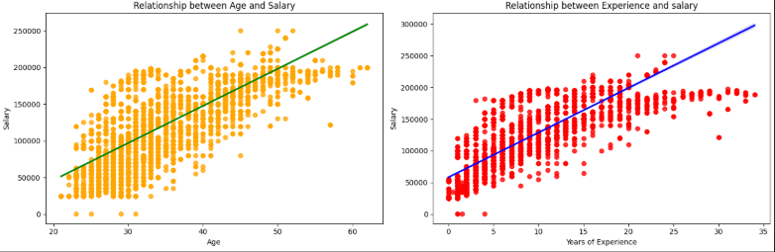
Figure 3: Relationship between Age - Salary, Year of Experience vs Salary

Workforce Composition (Job Titles)
An analysis of Job Title frequency provided context on the organization's workforce composition. The data showed the relative headcount for various roles (e.g., Data Scientists, Software Engineers).
Business Implication: Understanding the headcount distribution is key for budgeting and resource allocation. Furthermore, analyzing the average salary within the top job titles (e.g., using a Box Plot of Salary by Top 10 Job Titles) is essential for establishing internal equity pay bands to ensure similar roles are compensated fairly.
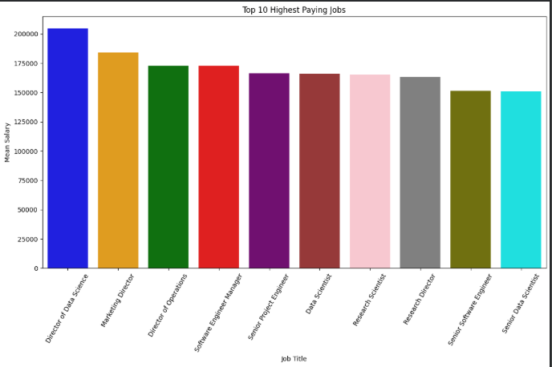
Figure 4: Top 10 Highest paying Job

Relationship between Educational Level vs Salary vs Gender
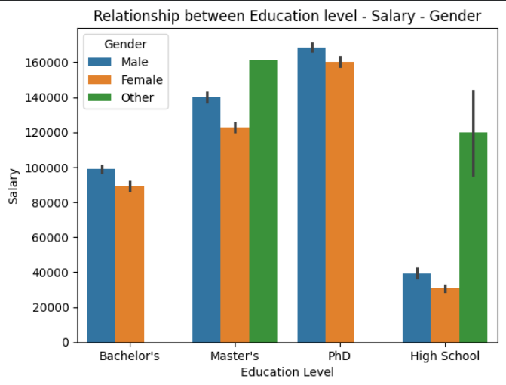
Figure 5: Relationship between Education Level - Salary - Gender

4. Feature Preprocessing for Actionable Data
The final stage of EDA involved transforming categorical data into a numerical format that machine learning algorithms can process.
Encoding Strategies: We used Ordinal Encoding for Education Level (reflecting the inherent order: Bachelor's < Master's < PhD) and One-Hot Encoding for Job Title.
Business Implication: These steps ensure that the model correctly interprets categorical features. For example, by converting Job Title into binary dummy variables, the model can assign a specific financial value (or penalty) to each role, which is essential for accurate job-level compensation modeling.
This rigorous EDA established a clean, well-understood dataset, ready to be translated into actionable predictive models.

